**CIS 260 - Lab 1 - SQL**

**Due February 11, 2016 by the start of class**

**Each problem is worth one point. No partial credit will be given. This lab is worth a total of 20 points.**

**Use the hostname: classdb.jccc.edu**

**Place all answers into ONE .sql file. Attach that file to the Dropbox for Lab 1 in D2L. Only one .sql file will be accepted.**

**1. An Oracle server stores information about all tables in a special set of relational tables**

**called the data dictionary, in order to manager them. Explain the term “data dictionary”.**

**2. Contrast and define the terms “metadata” and “data”.**

**3. Explain the purpose of the DESCRIBE table command?**

**\*\*\*\* The following questions use tables from the Student table space \*\*\*\***

**4. Using the DESCRIBE table command, create the following result table using the student**

**employee table.**

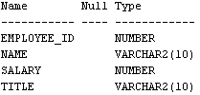

**5. Can the SELECT statement be used to alter data within a table? Explain your answer.**

**6. Display all rows and columns within the employee table.**

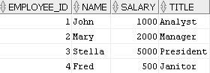

**7. List the students by last name followed by first name. Use the student table.**

**Partial result set (total of 268 rows)**

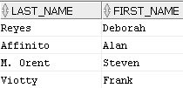

**8. List the students by last name followed by first name. Assign the label “FN” for a**

**student’s first name and “LN” for a student’s last name. Use the student table.**

**Partial result set (total of 268 rows)**

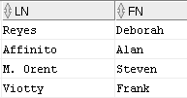

**9. List all unique zip codes. Use the student table.**

**Partial result set (total of 145 rows)**



**10. List the unique employers of the students and place them in ascending alphabetic order**

**(use the Order By clause). Use the student table.**

**Partial result set (total of 161 rows)**

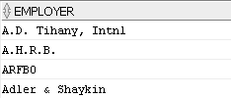

**11. List all students last names without any capitalization. Use the student table.**

**Partial result set (total of 268 rows)**

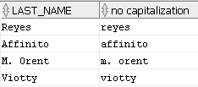

**12. List the first three characters of all course descriptions. Use the course table.**

**Partial result table (total of 30 rows)**

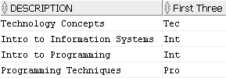

**13. List the last three characters of all course descriptions. Use the course table.**

**Partial result table (total of 30 rows)**

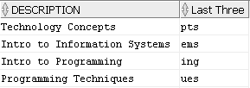

**\*\*\*\* The following questions use the dual table \*\*\*\***

**14. Explain what the dual table is used for.**

**15. Display all columns and rows of the Dual table.**



**16. Display the sum of 2 + 4 using the DUAL table.**



**17. Display 5 times 3, 5 minus 3, and 5 divided by 3. Use the Dual table.**



**18. Display 5 divided by 3 as a rounded value as per the following result table. Use the Dual**

**table. (Hint: to round to the number of decimal places, use (5/3,2) where the ,2 represents the number of places beyond the decimal point)**



**19. List the current date using the Dual table.**

**Of course, you need to display today’s current date.**



**20. List yesterday’s date using the Dual table.**

**Yesterday’s date based on today’s current date.**

